**­­­­­SMART MOVABLE ROAD DIVIDER USING IOT**

**Abstract:**

Road Divider is generically used for dividing the Road for ongoing and incoming traffic. This helps keeping the flow of traffic. Generally, there is equal number of lanes for both ongoing and incoming traffic. For example, in any city, there is industrial area or shopping area where the traffic generally flows in one direction in the morning or evening. The other side of Road divider is mostly either empty or under-utilized. This is true for peak morning and evening hours. This results in loss of time for the car owners, traffic jams as well as underutilization of available resources. Our idea is to formulate a mechanism of automated movable road divider that can shift lanes, so that we can have more number of lanes in the direction of the rush. The cumulative impact of the time and fuel that can be saved by adding even one extra lane to the direction of the rush will be significant. With the smart application proposed below, we will also eliminate the dependency on manual intervention and manual traffic coordination so that we can have a smarter traffic all over the city. An Automated movable road divider can provide a solution to the above-mentioned problem effectively. This is possible through IOT. IOT refers to Internet of Things where the actual digitalization comes into picture. Here sensors play a major role. We can achieve this using Arduino board. The sensors placed on the dividers sense the flow of traffic whether flow of traffic is smooth or not? If the flow is smooth on either side then there is nothing to worry but the lane which is having more traffic, the divider is moved to a certain distance to the smoother lane in order to smoothen the busy lane.

BLOCK DIAGRAM:

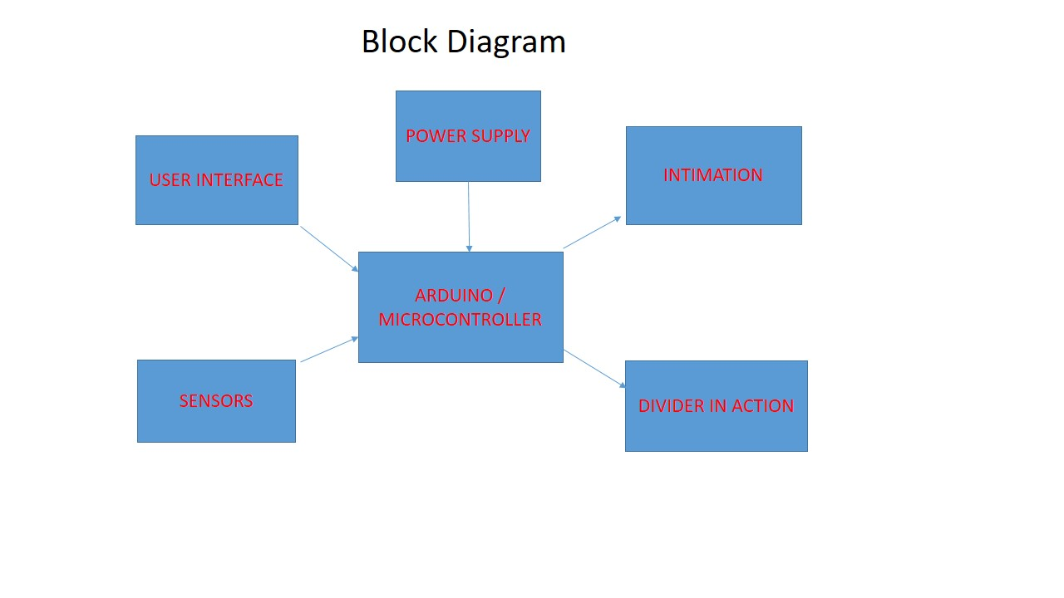

Figure: Smart Movable Road Divider

1. User interface
2. Multi Sensors
3. Arduino controller
4. Intimation for safe working environment
5. Divider in action : moving the divider depending on traffic

**Working Principle:**

Many IR sensors are deployed on the either side of the divider to detect the presence of density of vehicles , now depending on density of vehucles as determined by observing the IR sensors the divider is moved on either side to give more space for the traffic to flow smoothly in the densearea. LCD is used to display purpose to intimate the drivers to move away from the divider for the safety measures. MIT app which will be build to make the process manually by using GSM message detection. Node MCU is basically a wifi module which connects the local wifi network for internet and can be updated to the cloud website about the traffic status. Divider is moved with the help of motors. The Arduino is the brain of the project which controls the overall divider action and intimations.

**Software Required:**

Arduino IDE

MIT App Inventor 2 (website)

**Hardware Required:**

Arduino UNO

Node MCU

IR Sensors

Motors

Liquid Crystal Display- LCD

Power supply (Battery)

GSM / Bluetooth for Wireless Connectivity

Basic electronic components such as wires, solder, glue etc

Craft materials

**Conclusion:**

This project aims to reduce traffic by smartly sensing the traffic flow on either sides of the divider, and move the divider accordingly, hence saving the time and fuel. This also works on safety measures by intimating the drivers about the moment of the divider. This also allows the user i.e Traffic Police to manually control the divider position based on requirements.

**Reference:**

1. K. Vidhya, A. BazilaBanu, "Density Based Traffic Signal System", *Special*, vol. 3, no. 3, March 2014.
2. PriyankaKhanke, P. S. Kulkarni, A Technique on Road Tranc Analysis using Image Processing, vol. 3, no. 2, February 2014.
3. RajeshwariSundar, SanthoshsHebbar, VaraprasadGolla, "Implementing intelligent Traffic Control System for Congestion Control Ambulance Clearance and Stolen Vehicle Detection", *IEEE Sensors Journal*, vol. 15, no. 2, February 2015.
4. Ms.PallaviChoudekar, Ms.Sayanti Banerjee, M.K. Muju, Real Time Traffic Light Control Using Image Processing, vol. 2.
5. ShabbirBhusari, "Traffic control system using Raspberry-pi", *Global Journal of Advanced Engineering Technologies*, vol. 4, no. 4, pp. 413-415, MARCH 2015.
6. S. Lokesh, "An Adaptive Traffic Control System Using Raspberry PI", *International journal of engineering sciences & research Technology*, pp. 831-835, June 2014.
7. SoufieneDjahel, Reducing Emergency Services Response Time in Smart Cities: An Advanced Adaptive and Fuzzy Approach, IEEE, pp. 978-986, 2015.
8. George Kiokes, "Development of an Integrated Wireless Communication System for Connecting Electric Vehicles to the Power Grid", *IEEE conf.*, pp. 296-301, 2015.
9. Victor Welikhe, Graph Neuron based Approach to Smart Roads Solutions using Wireless Sensor Networks, IEEE, pp. 275-279, 2014.